
CpE-371: SOFTWARE ENGINEERING AND DEVELOPMENT



AMA-PLATFORM
Software Requirements Specification (SRS)

Version | v1.0
Status | Final
Date | 2026-10-31
Prepared by | Abdulrahman Bin Bahar, 2221130212, Abdulelah Al-Otaibi, 22221102706 , and Mohammed Jalwei, 2221137642

Department of Computer Engineering
College of Engineering and Petroleum
Kuwait University
2026 - 2027

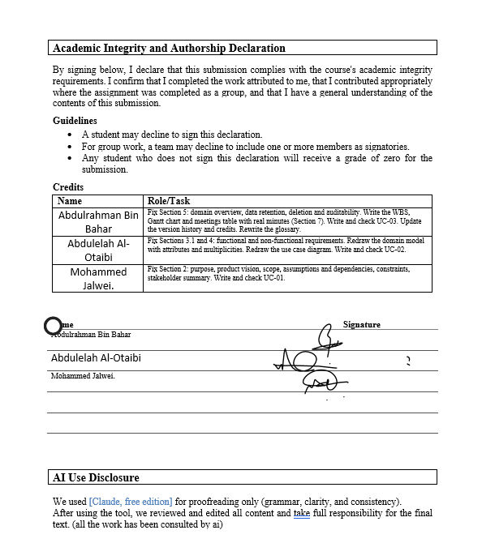Signature Page

I did my share of the work, and I have a general understanding of the contents of the assignment
Name Signature
Abdulrahman Bin Bahar Abdulrahman
Abdulelah Al-Otaibi Abdulelah
Mohammed Jalwei Mohammed

Report Evaluation
Criterion | Evidence / focus | Weight | Marks | Comments
Document control & professionalism | Version history, ownership, formatting, completeness | 5
Introduction & project framing | Purpose, scope, vision, constraints, assumptions, stakeholders | 10
Functional requirements | Clear, grouped, numbered, testable 'shall' statements | 15
Use-case model | Diagram, actors, use-case specs, traceability, coverage | 15
Non-functional requirements | Measurable NFRs with verification method | 10
Domain / data model | Domain overview, ERD/model, retention/deletion/auditability | 10
UI prototype & usability | Scenario coverage, key screens, findings, updates | 10
Project management & evidence | WBS, Gantt, refs, repo links, meeting records | 5
Team Deliverable Quality (Total) |  |  |  | out of 80
Individual Grade (20%)
Student name | Avg peer score  (/28) | Adjustment | Final mark  (/100) | Notes

Table of Contents
Contents
1
1. Document Control 6
1.1 Version history 6
1.2 Credits 6
1.3 Related documents / links 6
2. Introduction 7
2.1 Purpose 7
2.2 Product vision 7
2.3 Scope 7
2.4 Assumptions and dependencies 7
2.5 Constraints 8
2.6 Stakeholder summary 8
2.7 Overview 8
3. Functional Requirements and Use-case Model 8
3.1 Functional requirements 8
3.2 Use Case Model 11
4. Non-functional Requirements 14
5. Domain overview 17
5.2 Domain model 17
5.3 Data retention, deletion, and auditability 17
6. UI Prototype and Usability Evaluation 18
6.1 Prototype link(s) 18
6.2 Key screens and states 18
6.3 Usability evaluation 19
7. Appendix 20
7.1 References 20
7.2 Project Management 20
Work Breakdown Structure 20
Gantt Chart 22
Team Meetings 23

List of Abbreviations
Abbreviation | Meaning
WBS | Work Breakdown Structure
UC | Use Case
FR | Functional Requirement
SRS | Software Requirements Specification
ERD | Entity-Relationship Diagram
UI | User Interface
NFR | Non-functional Requirement
KPI | Key Performance Indicator

Glossary
Student | A user who searches for a suitable tutor and requests a tutoring session.
Availability | The time slots during which a tutor is available to give sessions.
Tutor | A user whose job is to provide tutoring sessions.
Coordinator | A user who is responsible for coordinating between students and tutors and who manages sessions.
Dispute | A complaint between a student and a tutor that is reviewed by a Coordinator.
Waitlist | A list of session requests that have no linked tutor and are waiting for an available session.
Session | A tutoring session that exists after the tutor accepts the request.
Session request | A request from a student for a tutoring session at a specific time and on a specific subject.
Session offer | An offer that is sent to the first student on the waitlist.
Exception request | A request that breaks a session rule and needs a Coordinator’s approval.

1. Document Control

1.1 Version history
Version | Date | Author | Change summary | Approval
0.1 | 17/10/2026 | Abdulrahman | Part 1: Sections 1 to 3 and 7 | Approved by team
0.2 | 24/10/2026 | Abdulrahman | Part 2: Sections 4, 5 and 7 | Approved by team
1.0 | 31/10/2026 | Abdulrahman | Full report: Sections 1 to 5 corrected after feedback, Section 6 added, and all changes highlighted in yellow. | Approved by team

1.2 Credits
Name | Role/Task
Abdulrahman | Domain overview, Data retention, deletion, and auditability, Project Management Gantt Chart, and [UC-03]
Abdulelah | NFR, FR, domain model and [UC-02]
Mohammed | Purpose, Product vision, Scope, Assumptions and dependencies, Constraints Stakeholder summary, and [UC-01]

1.3 Related documents / links
- https://github.com/bhr992/Group-project.git

2. Introduction

2.1 Purpose
This SRS describes the requirements and scope of our platform. It can help and guide the stakeholders, testers, developers, and anyone who can participate in it during system development. It can ensure that all parties have the same understanding of the system.

2.2 Product vision
FOR Kuwait University students who need extra academic help.
WHO are looking for qualified peer tutors.
THE AMA-PLATFORM is an online tutoring management system.
THAT simplifies finding tutors and booking sessions with policy checks.
UNLIKE informal WhatsApp groups or manual scheduling.
OUR PRODUCT provides an organized university platform with coordinator’s supervision.

2.3 Scope
In Scope:
- Search and Filter Tutors: Students can search for available tutoring slots by course, topic, preferred time, and format (online or in-person).
- Session Requests: Students can send session requests with details on what they need help with, and tutors can accept or decline.
- User Accounts and Roles: Login and account management for students, tutors, and coordinators.
- Session Management: Handling booking confirmations, cancellations, and rescheduling according to system rules.
- Waitlist and Reminders: Automatic waitlisting when no tutor is available, and sending same-day reminders for upcoming sessions.
Out of scope / non-goals:
- Payments: Processing payments or credit card transactions directly inside the application.
- Video Recording: Recording online sessions or storing video files on our server.
- Multi Language Support: Translating the interface into multiple languages (we are focusing on one main language for now).
- Group sessions: all tutoring is strictly 1-on-1 for one tutor and one student.

2.4 Assumptions and dependencies
- Assumptions: Users (students and tutors) have valid university emails to create their accounts.
- Assumptions: Tutors are qualified for the subjects they sign up to teach.
- Dependencies: Requires a stable internet connection to send real-time requests and notifications.
- Dependencies: Relies on an external email/notification service to send session reminders.

2.5 Constraints
- Policy Constraints: We must keep student and tutor data private according to university privacy policies.
- Technical Constraints: The search page shall load in under 2 seconds on Chrome and Edge browsers.
- Operational Constraints: Maintenance or database updates should be done during off-peak hours, so sessions aren't interrupted.

2.6 Stakeholder summary
Role | Primary goals | Key needs / pain points | Priority (H/M/L)
Student | Find trusted tutors quickly and book study sessions easily. | Hard to find good tutors for tough engineering courses. | High
Tutor | Accept or reject session requests and manage their teaching schedule. | Disorganized session requests and unexpected student cancellations. | High
Coordinator | Verify tutor qualifications and step in when requests are unassigned. | Too much manual work to match students with the right tutors. | Medium

2.7 Overview
The remainder of this SRS is organized as follows: Section 3 describes functional requirements and use cases, Section 4 details non-functional requirements, Section 5 presents the domain and data model, Section 6 covers UI prototypes and usability testing, and Section 7 provides references and project management details.

3. Functional Requirements and Use-case Model

3.1 Functional requirements
FR-01: Search and Availability
FR-01.1 The system shall allow students to search for tutors by subject or topic name.
FR-01.2 The system shall allow students to search for available tutors within a selected time window.
FR-01.3 The system shall allow students to search for online or in-person tutoring sessions.
FR-01.4 The system shall allow tutors to publish the subjects and available times they offer for tutoring.
FR-02: Session Requests and Waitlist
FR-02.1 The system shall allow students to create and submit a tutoring session request.
FR-02.2 The system shall require students to enter the subject name, topic, time window, session format (online or in-person), and reason for the session request.
FR-02.3 The system shall allow students to choose a preferred tutor if they have one.
FR-02.4 The system shall allow students to view the status of their session requests.
FR-02.5 The system shall allow tutors to review session requests and accept or decline them with a reason.
FR-02.6 The system shall create a confirmed session after the tutor accepts the request and all session rules are satisfied.
FR-02.7 The system shall keep a record of each confirmed, rescheduled, and cancelled session.
FR-02.8 The system shall allow students and tutors to request a new time for an existing session.
FR-02.9 The system shall allow students and tutors to request a cancellation for an existing session.
FR-02.10 The system shall check if a session is cancelled at least 4 hours before the session starts and record if the cancellation is on time or late.
FR-02.11 The system shall send email reminder notifications to students and tutors on the same day as their confirmed tutoring sessions.
FR-02.12 The system shall allow students to join a waitlist if no eligible tutor is available for the requested subject and time window.
FR-02.13 The system shall order waitlist requests by submission time, where the oldest request has the highest priority.
FR-02.14 The system shall select the first eligible student from the waitlist and skip students who are not eligible for the available session.
FR-02.15 The system shall start the waitlist rematch process when a matching tutor becomes available, including within 60 seconds after a confirmed session is cancelled.
FR-02.16 The system shall send a session offer to the next eligible student when a matching tutoring session becomes available.
FR-02.17 The system shall allow students to accept or decline session offers received from the waitlist.
FR-02.18 The system shall mark a waitlist session offer as expired if the student does not accept or decline the offer within 10 minutes after it is sent.
FR-02.19 The system shall send the session offer to the next eligible student if the previous student declines the offer or the offer expires.
FR-03: Session Constraints
FR-03.1 The system shall check the tutor's confirmed sessions and prevent confirming a new session if there is time overlapping.
FR-03.2 The system shall check the tutor's eligibility for the requested subject before confirming the session and prevent confirmation if the tutor is not verified for that subject.
FR-03.3 The system shall check whether a student's tutoring hours, including the requested session, exceed 5 hours within a rolling 7-day period.
FR-03.4 The system shall send session requests that exceed the 5-hour tutoring limit within a rolling 7-day period to the coordinator for approval or rejection before confirming the session.
FR-03.5 The system shall check the time between submitting a session request and the session start time and reject the request if it is less than 2 hours.
FR-03.6 The system shall check the session duration and reject requests shorter than 30 minutes or longer than 120 minutes.
FR-04: Session Completion and Rating
FR-04.1 The system shall allow tutors to mark their sessions as completed after the session ends.
FR-04.2 The system shall allow students to rate sessions they attended after the sessions are marked as completed.
FR-05: Coordinator Functions
FR-05.1 The system shall allow Coordinators to verify tutors' eligibility to tutor specific subjects.
FR-05.2 The system shall allow Coordinators to approve or decline exception requests for student sessions with a reason.
FR-05.3 The system shall allow Coordinators to review disputes between students and tutors.
FR-06: User Authentication
FR-06.1 The system shall allow students, tutors, and Coordinators to log in to the application using their registered email and password.
FR-07: Audit Records
FR-07.1 The system shall record the user, action, and time when a session request is created, accepted, or declined.
FR-07.2 The system shall record the user, action, and time when a session is rescheduled, cancelled, or completed.
FR-07.3 The system shall record the user, action, and time when a session rule is checked, or an exception request is approved or declined.

3.2 Use Case Model
Figure 1 presents the main actors and use cases for ATA-PLATFORM. The model emphasizes three main use cases:

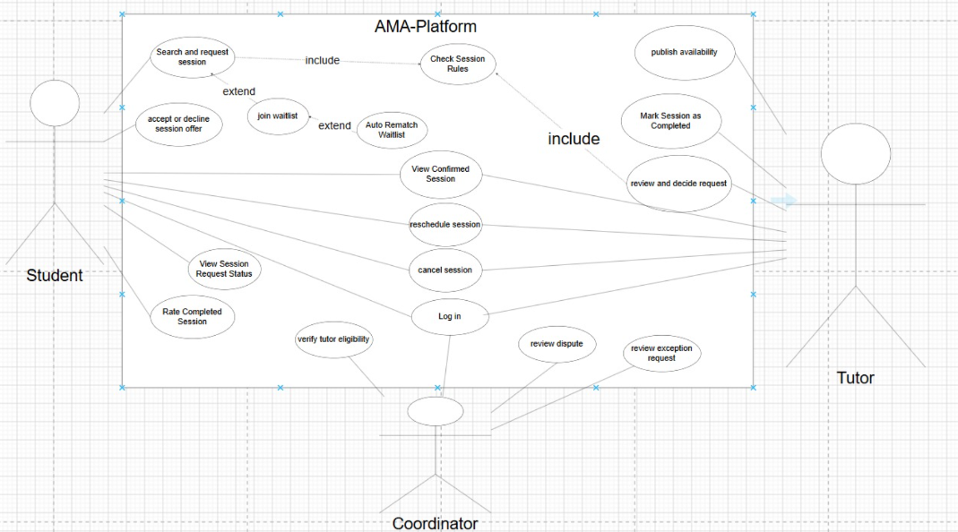
Figure 1. Use case diagram for AMA-PLATFORM

Use case UC- 1: Search and request session
Related Requirements | FR-01.1, FR-01.2, FR-01.3, FR-01.4, FR-02.1, FR-02.2, FR-02.3, FR-02.4, FR-02.5, FR-02.6, FR-02.7, FR-02.12, FR-02.13, FR-02.14, FR-02.15, FR-02.16, FR-02.17, FR-02.18, FR-02.19, FR-03.1, FR-03.2, FR-03.3, FR-03.4, FR-03.5, FR-03.6, FR-05.1, FR-05.2, FR-06.1, FR-07.1, FR-07.3.
Description (Goal) | To let students search for a suitable tutor at a time that suits them and make a request for a tutoring session, which the tutor then accepts or declines. If no tutor is available, the request is added to the waitlist.
Primary Actor(s) | Student
Secondary Actor(s) | Tutor, coordinator.
Preconditions | The student is logged into the system.  The tutor must publish his session times
Post-conditions | The session will be created and then sent to the tutor.  The session will be determined by the session rules.  The request will be recorded in the audit records.  A list will be displayed with tutors and their session time and subjects.
Related use cases | UC-02
Basic Flow | - Student logs into the system.  - Students search for tutors.  - The system willl display tutors.  - Tutors’ info will appear to students.  - The tutor is selected.  - The system shall send it to the tutor The student will enter the session.
Alternative Flow | The request will be rejected due to a constraint.  Tutor declines the request.  No suitable tutor found.  The request will be added to the waitlist.

Use case UC- 2: Manage confirmed session
Related Requirements | FR-02.7, FR-02.8, FR-02.9, FR-02.10, FR-02.11, FR-02.15, FR-06.1, FR-07.2
Description (Goal) | To let tutors and students view the confirmed session and the ability to cancel or reschedule it, to send a reminder on the day of the session via email.
Primary Actor(s) | Student, tutor
Secondary Actor(s) | Email, notification service.
Preconditions | 1.The student is logged into the system.  2.A confirmed session that exists.
Post-conditions | 1. The session will be canceled or rescheduled also recorded.  2. A cancellation will be recorded as late or on time.  3. On the day of the session a reminder will be sent.  4. Any action that has been made from the student or tutor will be at audit records.
Related use cases | UC-01
Basic Flow | 1. The user opens View Confirmed Session.  2. The user requests a new time or a cancellation.  3. The system checks whether the cancellation is at least 4 hours before the start and records it as on time or late.  4. The system records the change and the audit record.  5. If cancelled, the system starts the waitlist rematch within 60 seconds.  6. On the day of each confirmed session, the system emails a reminder to the student and the tutor.
Alternative Flow | - The student or tutor views without changing anything.  - The cancelation is late and it can’t be made.

Use case UC- 3: Rate completed session
Related Requirements | FR-04.1, FR-04.2, FR-05.3, FR-06.1, FR-07.2
Description (Goal) | After the tutor marks the session completed, then the student can rate the session, coordinator can review any dispute about the session.
Primary Actor(s) | Student.
Secondary Actor(s) | Tutor, coordinator.
Preconditions | - The user is logged into the system.  - A confirmed session that exists, the session has ended.
Post-conditions | 1. The session is completed.  2. the rating of the student will be saved.  3. Any action that has been made from the student or tutor will be at audit records.
Related use cases | UC-1, UC-2
Basic Flow | 1. The tutor opens the finished session.  2. The tutor marks the session as completed.  3. The student opens the completed session.  4. The student submits a rating for the session.  5. The rating is saved, and every action made is recorded in the audit records.
Alternative Flow | - The student leaves the session without rating.  - A student or tutor submits a dispute about the session, and the Coordinator will review the it.

4. Non-functional Requirements
NFR-01: Performance
1.1 Tutor Search Response Time: The system shall return tutor search results within 2 seconds for at least 95% of searches under 100 concurrent users.
Verification Method: Test — Run 100 concurrent users searching for tutors and check that at least 95% of searches finish within 2 seconds.
1.2 Page Loading Time: The system shall load the login page, main menu, session request page, and user profile page within 3 seconds for at least 95% of requests under 100 concurrent users.
Verification Method: Test — Measure the loading time of these pages under 100 concurrent users and check that at least 95% load within 3 seconds.
1.3 Waitlist Rematch Time: The system shall start the waitlist rematch process within 60 seconds after a confirmed session is cancelled.
Verification Method: Test — Cancel a confirmed session and check that the rematch process starts within 60 seconds.
NFR-02: Usability
2.1 Login Time: At least 90% of first-time students, tutors, and Coordinators shall be able to log in within 3 minutes.
Verification Method: Test — Ask first-time users to log in and measure how many complete the task within 3 minutes.
2.2 Session Request Time: At least 90% of first-time students shall be able to submit their first tutoring session request within 2 minutes after opening the request form.
Verification Method: Test — Ask first-time students to submit a session request and measure the completion time.
2.3 Rescheduling Time: At least 90% of first-time students and tutors shall be able to submit a session rescheduling request within 2.5 minutes.
Verification Method: Test — Ask first-time students and tutors to request a new session time and measure the completion time.
2.4 Cancellation Time: At least 90% of first-time students and tutors shall be able to submit a session cancellation request within 3 minutes.
Verification Method: Test — Ask first-time students and tutors to request a cancellation and measure the completion time.
2.5 Tutor Availability Publishing Time: At least 90% of first-time tutors shall be able to publish a subject, topic, and available session times within 3 minutes.
Verification Method: Test — Ask first-time tutors to publish their availability and measure the completion time.
2.6 Exception Review Time: At least 90% of first-time Coordinators shall be able to review and approve or decline an exception request within 3 minutes.
Verification Method: Test — Ask first-time Coordinators to review an exception request and measure the completion time.
NFR-03: Security
3.1 Password Protection: The system shall store user passwords using salted password hashing and shall not store passwords as plain text.
Verification Method: Inspection — Check the password storage method and verify that passwords are stored as salted hashes.
3.2 Email Verification: The system shall require users to verify their registered university email using a verification code before activating their accounts.
Verification Method: Test — Try activating an account with a valid and invalid verification code and check the results.
3.3 Login Authentication: The system shall require users to enter their registered email and password to log in.
Verification Method: Test — Try logging in with correct and incorrect account information.
3.4 Role-Based Access: The system shall allow students, tutors, and Coordinators to access only the information and functions allowed for their roles.
Verification Method: Test — Log in using each role and check that users cannot access functions or records outside their permissions.
NFR-04: Privacy
4.1 Student Information Privacy: The system shall allow students to view only their own personal information and session records.
Verification Method: Test — Log in as different students and check that each student can access only their own records.
4.2 Tutor Information Access: The system shall allow tutors to view only the student information and session records needed for requests assigned to them.
Verification Method: Test — Log in as a tutor and try to access records of students who have not requested sessions with that tutor.
4.3 Contact Information Privacy: The system shall hide students' and tutors' contact information until both sides confirm the tutoring session.
Verification Method: Test — Check whether contact information is hidden before confirmation and available to the confirmed participants afterward.
NFR-05: Reliability and Availability
5.1 System Availability: The system shall maintain at least 99% monthly availability, excluding scheduled maintenance periods.
Verification Method: Monitoring — Record system uptime and downtime during each month and calculate the availability percentage.
5.2 Maintenance Notification: The system shall notify users at least 24 hours before scheduled maintenance that may affect system availability.
Verification Method: Inspection — Check the notification time and compare it with the scheduled maintenance start time.
5.3 Data Recovery: The system shall keep all committed session requests, sessions, ratings, and audit records after a system restarts without losing any committed records.
Verification Method: Test — Save records, restart the system, and check that all committed records are still available.
NFR-06: Maintainability
6.1 Unit Test Coverage: The system shall maintain at least 70% unit test coverage for the main functions of session requests, session confirmation, and waitlist rematching.
Verification Method: Analysis — Run the unit test coverage report and check that the coverage is at least 70%.
6.2 System Configuration: The system shall allow the 5-hour tutoring limit, session duration limits, and waitlist offer expiration time to be changed through configuration settings without changing the source code.
Verification Method: Test — Change the waitlist offer expiration time and check that the system applies the new value without changing the source code.

5. Domain overview
The AMA-PLATFORM domain focuses on the lifecycle of a tutoring session. A Student searches for a preferred Tutor and submits a Session Request. The system then checks the session rules, and if a request violates any session rule, it becomes an Exception Request, which the coordinator can either approve or deny. The Tutor can accept or decline the request. If no Tutor is available, the request is added to the waitlist. If a session is cancelled, an offer is sent to the first eligible student on the waitlist. After the session is completed, the Tutor marks it as completed, and the student can then leave a Rating. Tutors and Students can submit Disputes, which are reviewed by the coordinator. Notifications confirm and remind Tutors and Students, while Audit Records log every state-changing action.

5.2 Domain model
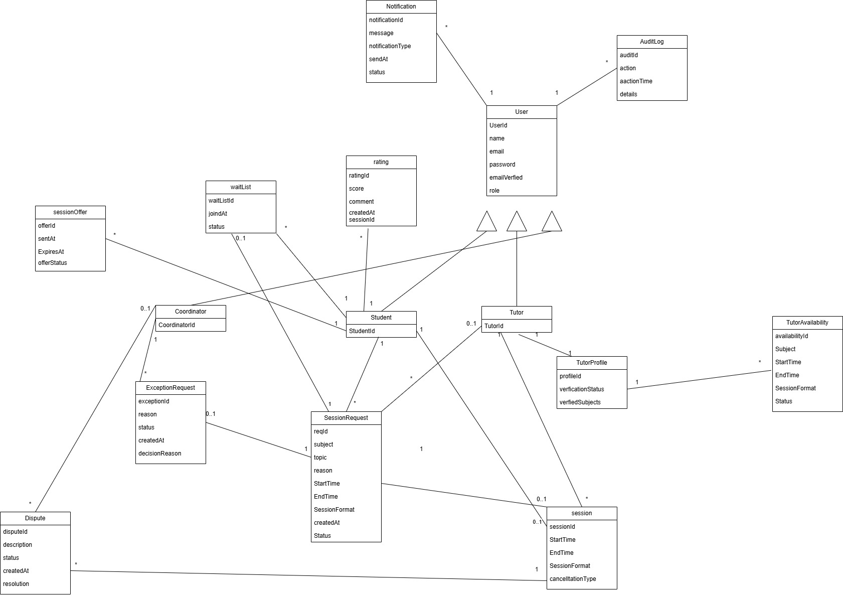
Figure 2. High-level domain model for AMA-PLATFORM

5.3 Data retention, deletion, and auditability
- The system shall keep session requests, sessions, notifications and ratings for 12 months for operational reporting and dispute handling and then delete them from the system.
- Retention: The system shall preserve audit records for a minimum of 150 days.
- Deletion: The system shall warn the students, tutors, and coordinators by email after 180 days without logging in. if the user did not log in within 30 days after the warning, the system shall deactivate the account and delete the user’s info.
- Audit: The system shall record the user, activity and timestamp for session request creation and decisions, session updates, session rule validations and exception decisions.
- Auditability: Every session request and session shall be traceable to the user and the timestamp of each activity while its audit record is stored.

6. UI Prototype and Usability Evaluation
If the product is UI-heavy, include a prototype and a brief evaluation to reduce ambiguity and rework.
[Create a UI prototype covering a scenario for each main use case (e.g. if you have 3 main use cases, cover 3 scenarios, and so on) using Invision app. Create the screens using some proper software tool then connect them on Invision app. Make sure to show data in the scenarios (e.g. in case of a login form show it first empty then when the user clicks on it show the data filled in the fields).]
The goal of this prototype is elicit requirement from the customer using prototyping based on scenarios from the requirement specifications. This prototype is be able to handle < your number of main use cases > scenarios. It was tested on [3] users.

6.1 Prototype link(s)
- Figma / prototype: [link]

6.2 Key screens and states
[Create a prototype of your system on invision app covering the < your number of main use cases > chosen scenarios. Create the screens using proper software tools then connect them on Invision app. Make sure to show data in the scenarios. Include the invision app link here. In addition, describe your preliminary design by presenting pictures of important screens and briefly explaining the function of each screen.]
This section of the document contains brief descriptions of the main screens in <name of your application>. Each screen in the system shows the behavior and state changes that the user will experience when pressing a button or choosing an option on the screen. InVision App online prototyping tool was used to create all of the system screens. The UI interactive prototype is available online at this <your invision app link>.

- ……… Screen (e.g. Login Screen)
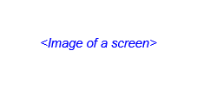
Figure 2 .... Screen
Description: …………………………………………………………………..

- ……… Screen

Figure 3 ..... Screen
Description: …………………………………………………………………..

6.3 Usability evaluation
Scenario ID | Scenario | Participants | Findings | Action / requirement update
UE-0X | [User tries to …] | [N users, profile] | [What worked / what failed] | [Change to story/NFR/UI]
UE-0X | [User tries to …] | [N users, profile] | [What worked / what failed] | [Change to story/NFR/UI]
UE-0X | [User tries to …] | [N users, profile] | [What worked / what failed] | [Change to story/NFR/UI]
UE-0X | [User tries to …] | [N users, profile] | [What worked / what failed] | [Change to story/NFR/UI]

7. Appendix

7.1 References
- Course notes, lecture slides, and instructor feedback for CpE-371 Software Engineering and Development.

7.2 Project Management

Work Breakdown Structure
ID | Task name | Duration | Start | Finish | Pred. | Resources
1 | Project proposal | 4 d | 2026-10-2 | 2026-10-5 | - | Team
2 | Project Description | 4 d | 2026-10-2 | 2026-10-5 | - | Team
3 | Project proposal submission | 0 d | 2026-10-5 | 2026-10-5 | 2 | Abdulrahman
4 | SRS Part 1 | 3 d | 2026-10-15 | 2026-11-17 | - | Team
5 | Document Control | 3 d | 2026-10-15 | 2026-10-17 | - | Mohammed
6 | Introduction | 3 d | 2026-10-15 | 2026-10-17 | 2 | Mohammed
7 | Purpose | 3 d | 2026-10-15 | 2026-10-17 | 2 | Mohammed
8 | Product vision | 3 d | 2026-10-15 | 2026-10-16 | 7 | Mohammed
9 | Scope | 3 d | 2026-10-15 | 2026-10-17 | 8 | Mohammed
10 | Assumptions and dependencies | 3 d | 2026-10-15 | 2026-10-17 | 9 | Mohammed
11 | Constraints | 3 d | 2026-10-15 | 2026-10-17 | 10 | Mohammed
12 | Stakeholder summary | 3 d | 2026-10-15 | 2026-10-17 | 2 | Mohammed
13 | Overview | 3 d | 2026-10-15 | 2026-10-17 | - | Mohammed
14 | Functional Requirements and Use-case Model | 3 d | 2026-10-15 | 2026-10-17 | - | Abdulelah
15 | Functional requirements | 3 d | 2026-10-15 | 2026-10-17 | 2 | Abdulelah
16 | Use Case Model | 3 d | 2026-10-15 | 2026-10-17 | 15 | Abdulelah
17 | Appendix | 3 d | 2026-10-15 | 2026-10-16 | - | Abdulrahman
18 | References | 3 d | 2026-10-15 | 2026-10-17 | - | Abdulrahman
19 | Project Management | 3 d | 2026-10-15 | 2026-10-17 | - | Abdulrahman
20 | Work Breakdown Structure | 3 d | 2026-10-15 | 2026-10-17 | - | Abdulrahman
21 | Gantt Chart | 3 d | 2026-10-15 | 2026-10-17 | 20 | Abdulrahman
22 | SRS Part 1 submission | 0 d | 2026-10-17 | 2026-10-17 | 21 | Abdulrahman
23 | SRS Part 2 | 3 d | 2026-9-22 | 2026-10-24 | - | Team
24 | Non-functional Requirements | 3 d | 2026-10-22 | 2026-10-24 | 2 | Abdulelah
25 | Domain overview | 3 d | 2026-10-22 | 2026-10-24 | 16 | Abdulrahman
26 | Domain model | 3 d | 2026-10-22 | 2026-10-24 | 25 | Abdulelah
27 | Data retention, deletion, and auditability | 3 d | 2026-10-22 | 2026-10-24 | 26 | Abdulrahman
28 | Review Appendix | 3 d | 2026-10-22 | 2026-10-24 | 23 | Abdulrahman
29 | SRS Part 2 Submission | 0 d | 2026-10-24 | 2026-10-24 | 28 | Abdulrahman
30 | SRS Final | 3 d | 2026-10-29 | 2026-10-31 | - | Team
31 | Review Part 1 and 2 | 3 d | 2026-10-29 | 2026-10-31 | 29 | Team
32 | Final Submission | 3 d | 2026-10-31 | 2026-10-31 | 31 | Abdulrahman

Gantt Chart
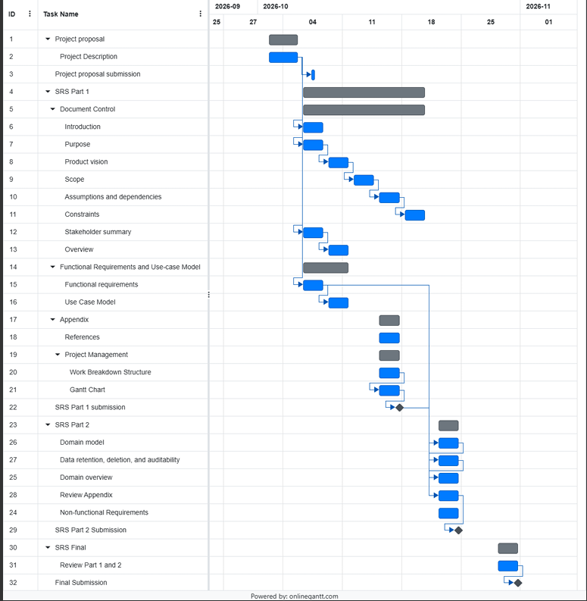
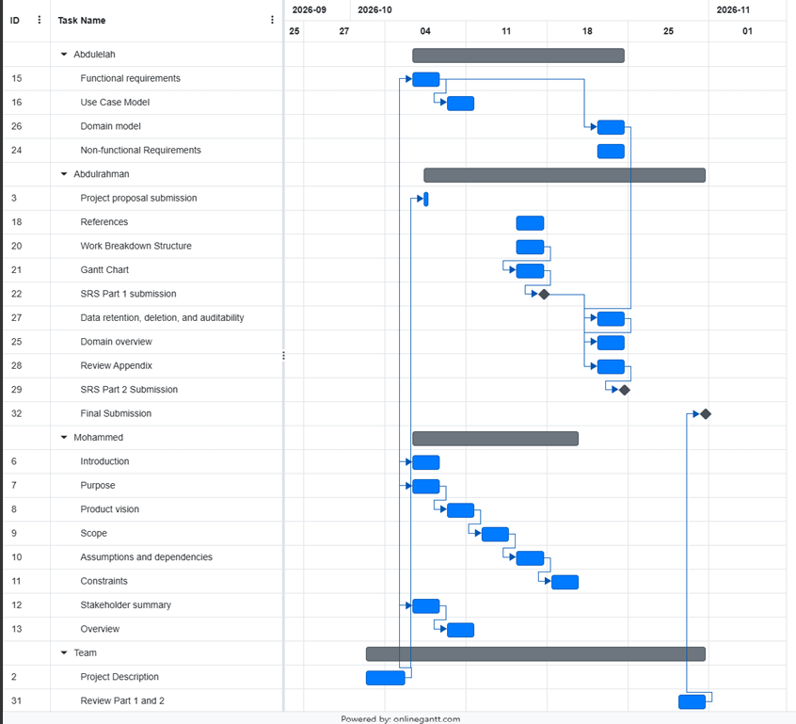
https://github.com/bhr992/Group-project.git

Team Meetings
On Github.

